

### Physics Laboratory Vp241

Exercise 2

The Hall Probe: Characteristics and Applications

This lab manual is based on materials provided by the Department of Physics, Shanghai Jiaotong University.

Edited by: Qin Tian, Wang Zhiyu, Mateusz Krzyzosiak rev. 3.6

# Pre-lab Reading

Chapter 27, section 9 (Young and Freedman)

# Objectives

In 1879 E.H. Hall observed that when an electric current passes through a sample placed in a magnetic field, electric potential difference proportional to the current and to the magnetic field appears across the material in the direction perpendicular to both the current and the magnetic field. This effect is known as the Hall effect, and since its discovery it has found many practical applications. The principle of the Hall effect is used in devices for magnetic field measurements as well as in position and motion detectors.

The objective of this exercise is to study the principle of the Hall effect and its ap- plications by using a Hall probe. In particular, it will be verified that the Hall voltage is proportional to the magnetic field. Furthermore, the sensitivity of an integrated Hall probe will be studied by calculating the magnetic field at the center of a solenoid, and the magnetic field distribution along the axis of the solenoid will be measured and compared with the corresponding theoretical curve.

# Theoretical Background

## Hall Effect

Consider a conducting sheet (made of a metal or a semiconductor) placed in a magnetic field so that the plane of the sheet is perpendicular to the direction of the magnetic field **B** (Figure 1). When the electric current *I* passes through the sheet in the direction shown in Figure 1, an electric potential difference between the sides *a* and *b* of the sheet is generated. The corresponding electric field is perpendicular to both the direction of the current and the direction of the magnetic field. This effect is known as the Hall effect, and the electric potential difference is called the Hall voltage *U*H.

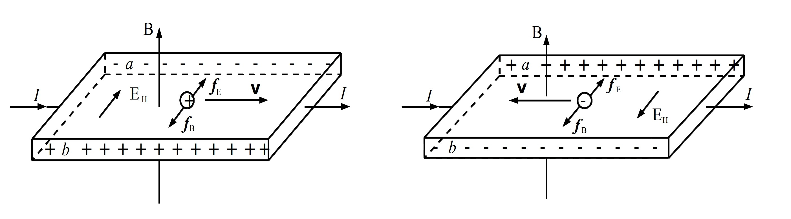

Figure 1. The principle of the Hall effect.

Microscopically, the Hall effect is caused by the Lorentz force, that is a force acting on charges moving in a magnetic field. The Lorentz force **F***B* leads to the deflection of the moving charges, and their accumulation on one side of the sheet, which in turn increases the magnitude of the transverse electric field **E***H* (the Hall field). Due to this field, there is an electric force **F***E* acting upon the charges, and since **F***B* and **F***E* act in opposite directions, a balance is eventually reached and *U*H stabilizes. The sign of *U*H depends on the sign of the charge carriers (positive or negative). Therefore the type of charge carriers in semiconductors can be determined by analyzing the sign of *U*H.

When the external magnetic field is not too strong, the Hall voltage is proportional to both the current and the magnitude of the magnetic field, and inversely proportional to the thickness of the sheet *d*

*U*H = *R*H

*IB*

= *KIB,* (1)

*d*

where *R*H is the so-called Hall coefficient and *K* = *R*H*/d* = *KH /I*, where *KH* is the so-called sensitivity of the Hall element.

## Integrated Hall Probe

The magnitude of the magnetic field can be found by measuring the Hall voltage with a Hall probe when the sensitivity *K*H and the current *I* are fixed. Since the Hall voltage is usually very small, it should be amplified before the measurement.

Silicon can be used to design both the Hall probe and the integrated circuits, so it is convenient to arrange the Hall probe and the electric circuits into a single device. Such a device is called an integrated Hall probe.

The integrated Hall probe SS495A consists of a Hall sensor, an amplifier, and a voltage compensator (Figure 2). The output voltage *U* can be read ignoring the residual voltage. The working voltage *U*S = 5 V, and the output voltage *U*0 is approximately 2.5 V when the magnetic field is zero. The relation between the output voltage *U* and the magnitude of the magnetic field is

*B* = *U* − *U*0

*K*H

(2)

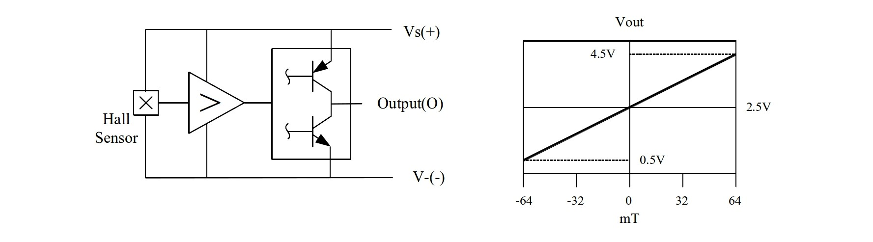

Figure 2. The integrated Hall probe SS495A (left). The relation between the output voltage *U* and the magnitude of the magnetic field *B* (right).

## Magnetic Field Distribution Inside a Solenoid

The magnetic field distribution on the axis of a single layer solenoid can be calculated from the following formula

*N* ( *L* + 2*x*

*L* − 2*x*

*B*(*x*) = *µ*0 *L I*M

1

2 [*D*2 + (*L* + 2*x*)2] 2

+

2 [*D*2

+ (*L* −

1

2*x*)2] 2

= *C*(*x*)*I*M*,* (3)

where *N* is the number of turns of the solenoid, *L* is its length, *I*M is the current through the solenoid wire, and *D* is the solenoid’s diameter. The magnetic permeability of vacuum is *µ*0 = 4*π* × 10*−*7 H/m.

The solenoid used in this exercise has ten layers, and the magnetic field *B*(*x*) for

each layer can be calculated using Eq. (3). Then the net magnetic on the axis of the solenoid can be found by adding contributions due to all layers. The theoretical value of the magnetic field inside the solenoid with *IM* = 0*.*1 A is given in Table 1.

|  |  |  |  |
| --- | --- | --- | --- |
| *x* [cm] | *B* [mT] | *x* [cm] | *B* [mT] |
| ±0*.*0 | 1.4366 | ±8*.*0 | 1.4057 |
| ±1*.*0 | 1.4363 | ±9*.*0 | 1.3856 |
| ±2*.*0 | 1.4356 | ±10*.*0 | 1.3478 |
| ±3*.*0 | 1.4343 | ±11*.*0 | 1.2685 |
| ±4*.*0 | 1.4323 | ±11*.*5 | 1.1963 |
| ±5*.*0 | 1.4292 | ±12*.*0 | 1.0863 |
| ±6*.*0 | 1.4245 | ±12*.*5 | 0.9261 |
| ±7*.*0 | 1.4173 | ±13*.*0 | 0.7233 |

Table 1. Theoretical value of the magnetic field inside the solenoid.

## Study of the Geomagnetic Field with a Hall Probe (op- tional)

The geomagnetic field is the magnetic associated with the Earth. The geomagnetic field lines are shown schematically in Figure 3. The Earth’s magnetic field is similar to that of a bar magnet tilted about 11.5*◦* degrees from the spin axis of the Earth.

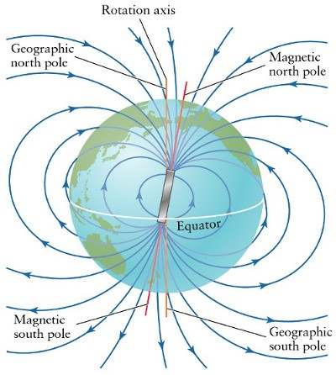

Figure 3. Magnetic field of the Earth.

Figure 4 shows the geomagnetic field distribution of China in 1970. The magnetic inclination is about 44*.*5*◦* and the magnitude of the magnetic field in Shanghai is about 48000 nT.

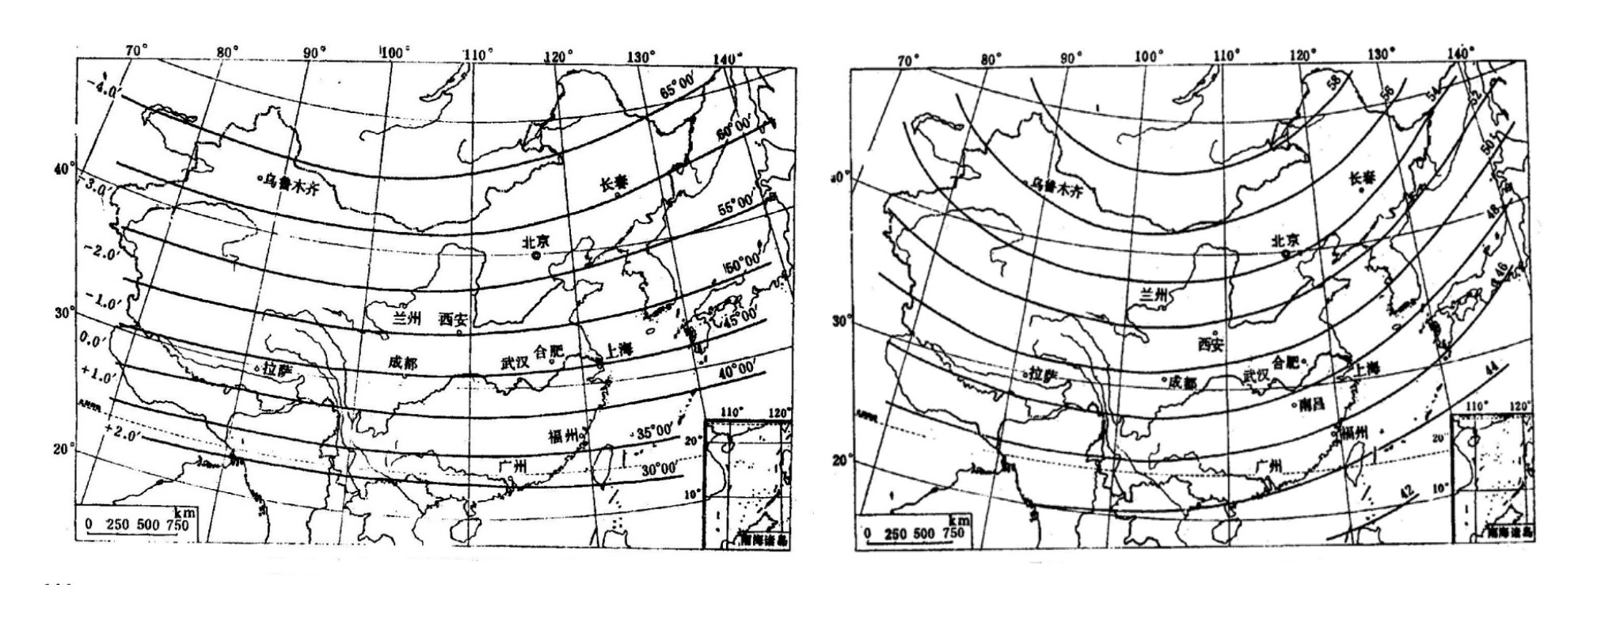

Figure 4. Geomagnetic inclination in China, 1970 (left). The magnitude of the geomag- netic field in China, 1970 (right).

# Measurement Setup and Procedure

## Apparatus

The experimental setup shown in Figure 5 consists of an integrated Hall probe SS495A (see Figure 6) with *K*H = 31*.*25 ± 1*.*25 V/T or *K*H = 3*.*125 ± 0*.*125 mV/G, a solenoid, a power supply, a voltmeter, a DC voltage divider, and a set of connecting wires.

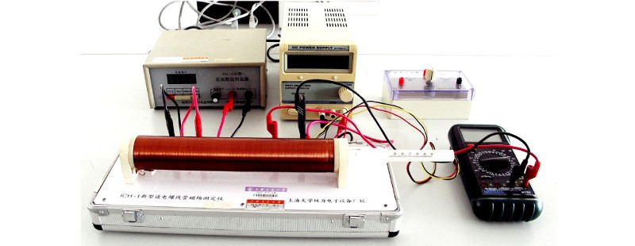

Figure 5. Measurement setup.

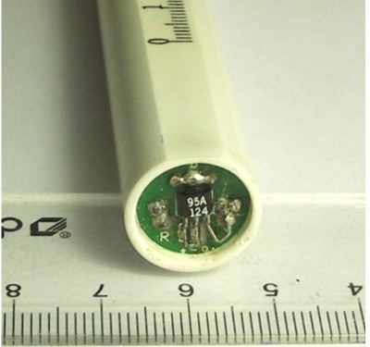

Figure 6. Integrated Hall probe SS495A.

## Measurement Procedure

#### Relation Between Sensitivity *K*H and Working Voltage *US*

* + - 1. Place the integrated Hall probe at the center of the solenoid. Set the working voltage at 5 V and measure the output voltage *U*0 (*I*M = 0) and *U* (*I*M = 250 mA). Take the theoretical value of *B*(*x* = 0) from Table 1 and calculate the sensitivity of the probe *K*H by using Eq. (2).
      2. Measure *K*H for different values of *U*S (from 2.8 V to 10 V). Calculate *K*H*/US* and plot the curve *K*H*/U*S vs. *U*S.

#### Relation Between Output Voltage *U* and Magnetic Field *B*

* + - 1. With *B*=0, *U*S=5 V, connect the 2*.*4 ∼ 2*.*6 V output terminal of the DC voltage divider and the negative port of the voltmeter. Adjust the voltage until *U*0 = 0.
      2. Place the integrated Hall probe at the center of the solenoid and measure the output voltage *U* for different values of *I*M ranging from 0 to 500 mA, with intervals of 50 mA.
      3. Explain the relation between *B*(*x* = 0) and the Hall voltage *U*H. Pay attention to the fact that the output voltage *U* is the amplified signal from *U*H. The theoretical value of *B*(*x* = 0) can be found from Table 1.
      4. Plot the curve *U* vs. *B* and find the sensitivity *K*H by a linear fit (use a computer). Compare the value you obtained with the theoretical value in given in the *Apparatus* section.

#### Magnetic Field Distribution Inside the Solenoid

* + - 1. Measure the magnetic field distribution along the axis of the solenoid for *I*M = 250 mA, record the output voltage *U* and the corresponding position *x*. Then find *B* = *B*(*x*). (Use the value of *K*H found in the previous part of the experiment).
      2. Use a computer to plot the theoretical and the experimental curve showing the magnetic field distribution inside the solenoid. Use dots for the data measured and a solid line for the theoretical curve. The origin of the plot should be at the center of the solenoid.

#### Measurement of the Geomagnetic Field (optional)

* + - 1. Use the integrated Hall probe to measure the magnitude and the direction of the geomagnetic field.

# Cautions

� Make sure that the *V* + port and the *V* − port of the integrated Hall probe **are connected correctly**, otherwise the probe will get damaged.

� After turning the power supply on, please wait for 5 minutes before starting mea- surements, in order to let the power supply temperature reach a steady state.

� Working voltage *U*S must be lower than 10 V for measurements described in part 4.2.1.

� Set the output voltage and the current to zero before turning off the power supply.

� Turn off the power supply before disassembling the equipment.

# Preview Questions and Exercises

� Qualitatively describe the process leading to the generation of the Hall voltage.

� Derive Eq. (1).

� What does the integrated Hall probe SS495A consist of and what is the role of each part?

� Explain the working principle of the circuit in Figure 2.

� What is the magnetic inclination? Sketch its direction with respect to the Earth’s surface.

� Use a computer to plot the relation *B* = *B*(*x*) using the numerical data in Table 1.

� Design a procedure for measuring the geomagnetic field.